How to Complete Your HC Volunteer Paperwork

Follow this link to the HC UltraCamp Site
https://www.ultracamp.com/info/downloaddocuments.aspx?idCamp=463&campcode=hnc&lang=en-Us

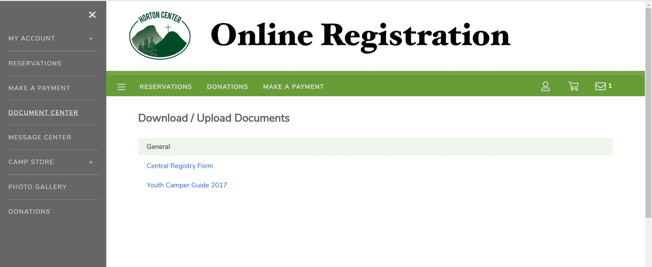
1. Navigate to the Document Center Click on the menu button to the left of ‘Reservations’ at the top of the screen. Select ‘Document Center’, then scroll down to ‘Volunteer Forms’.

All volunteer forms are under the ‘Volunteer Forms’ heading. Here are the forms you will need to complete:

NEW Volunteers
- Step 1: HC Volunteer Application
- Step 2: ACA Voluntary Disclosure Statement
- Step 3: Health History for Adults
- Step 4: HC Volunteer Background Check Form
- Step 5: DCYF Name Search Authorization Release (Required for current NH residents and anyone who has been a NH resident any time in the past 7 years) Must be printed, completed, and notarized before mailing to the NH Conference Office: 140 Sheep Davis Rd, Pembroke, NH 03275

RETURNING Volunteers
- Step 1: HC Volunteer Application *update and submit*
- Step 2: ACA Voluntary Disclosure Statement *update and submit*
- Step 3: Health History for Adults *update and submit*
- Step 4: HC Volunteer Background Check Form
- Step 5: DCYF Name Search Authorization Release (Required for current NH residents and anyone who has been a NH resident any time in the past 7 years) Must be printed, completed, and notarized before mailing to the NH Conference Office: 140 Sheep Davis Rd, Pembroke, NH 03275

- Login or Create an Account Click on the Step 1 form (HC Volunteer Application), and create an UltraCamp account or login with an existing account.
New volunteer at Horton Center? For right now, simply complete Step 1 – the HC Volunteer Application. A director will be in touch with you soon!
Note: You must be the primary contact on the account. If you have been a camper, you must create your own separate account from the one through which your guardians registered you for camp.

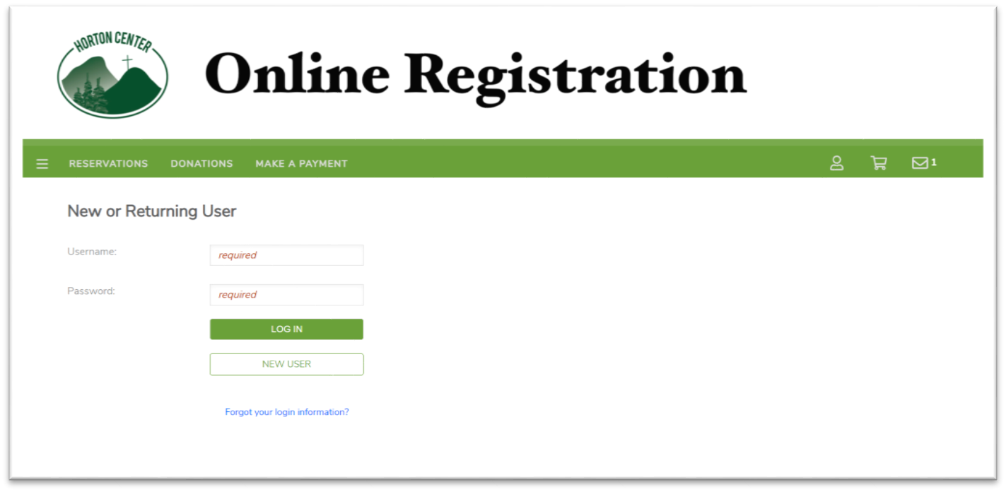

- Select your Name You will then see a screen asking you to select the person you want to complete the form for, select your name.
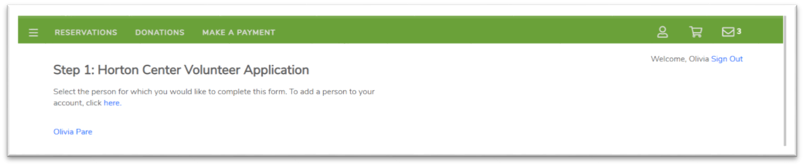

- Complete the Form and SAVE After you fill out the form, it will ask you to create an electronic signature to complete the form. Click SAVE to submit the form.

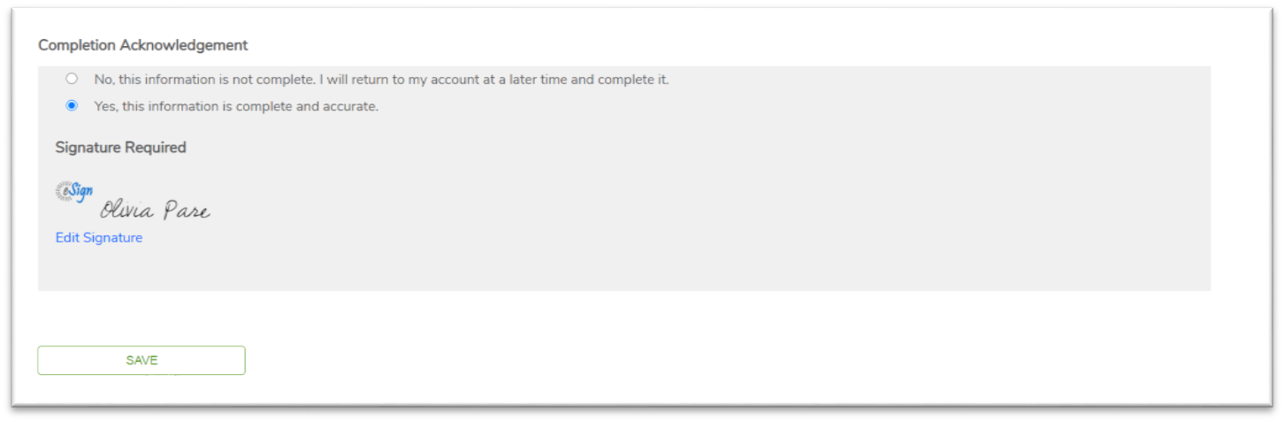

- Go to the Next Form After you’ve completed a form, you’ll return to your home screen. If you would like to, please go ahead and complete the rest of your paperwork now.
To see your completed forms, click on the plus sign (+) for the My Forms section.
To complete another form, you can click on “Complete a new form” in the My Forms section.

Note: For the document titled “Step 6: DCYF Name Search Authorization Release”, the link (must be copied and pasted into a new tab of your browser) to the form can be located within Step 6. After you have followed the link to the actual form itself, print, complete and mail it to the NH Conference Office (140 Sheep Davis Rd. Pembroke, NH 03275).

As you complete each form, you will receive an email confirmation.

